Software Requirement Specification Document

For

Event Ticket Booking System

Table of Contents
Page Numbers
- Introduction
  - Purpose 3
  - Intended Customers/Users 3
  - Product Scope ` 4
  - Outline of the document 4
- Overall Description
  - Product Perspective 5
  - Product Functions 5
  - User Classes 5-6
  - Design and Implementation Constraints 6
- Diagrams
  - UML Diagrams 7-32
  - ER Diagrams 33
  - DFD Diagrams 34
- External Interface Requirements
  - User Interfaces 34-35
  - Hardware Interfaces 35
  - Software Interfaces 35
  - Communication Interfaces 35
- Other Non-Functional Requirements
  - Performance Requirements 36
  - Safety Requirements 36
  - Security Requirements 36
  - Software Quality Attributes 36-37
  - Business Policies/Rules (if any) 37
- Testing
  - White-Box Testing 38-41,46-49
  - Black-Box Testing 42-45,50-52
- Conclusion 52
- References 53
- Acknowledgements 53

1.INTRODUCTION

The rapid growth of digital technologies has transformed the way events are organized and managed in educational institutions.Manual event registration is time-consuming, complex and error-prone.To overcome these challenges,an automated system is required to efficiently handle event registration.
The Event Ticket Booking System is a Java-based Software application designed to simplify the process of registrations in various colleges across India registered as institutes.It provides a centralized platform wherestudentscanviewandregister fortheir availableevents.The system ensures better organization,transparency,and ease of access for both students and event organizers.

  - Purpose
- The purpose of developing the Event Ticket Booking System is to provide an efficient and easy way to manage event registration and ticket bookings in colleges.Traditional methods are time-consuming,faulty,and difficult to manage as the number of participants increases.This system is designed to simplify the process by allowing students to easily view available events,register through a single system.
- This system solves problems such as long registration queues,manual recording,difficulty in tracking registered events.By digitizing the process,which increases accuracy,saves time, and ensures better organization of college events.
- This Software Requirements Specification(SRS) document provides a complete description of system’s working,features, constraints,and requirements.It serves as a reference for developers and evaluators to understand what the system does.

1.2 Intended Customers/Users
The Intended users of the Event Ticket Booking System include:
- Students:
- To view available events
- Register for events
- Make Payments if required
- Event Organizers:
  - To manage events
  - View registered participants
- College Administration:
- To Oversee event activities
- To ensure smooth event registration processes.
  - Product Scope
- The Event Ticket Booking System allows users to select their college if registered in database as an institute,enter the student ID(given uniquely for each college),view available events,and register for selectedevents
- The system supports multiple event types such as movie,coding,dance,fitness,meetup,culturals, and other technical or non-technical events.
- It handles both free and paid events,redirects users to payment process if needed,generates registration receipts, and maintains a list of registered events for each user.
- The system aims to reduce a manual work,improve accuracy,and provide a user-friendly event registration experience.

  - Outline of the Document
This document is organized as follows:
- Chapter 1-Introduction
Explains the purpose of the system, who will use it, the scope of the project, and how the document is organized.
- Chapter 2-Overall Description
Gives a general overview of the system, including its main features, user types, and important constraints to be considered during development.
- Chapter 3-Diagrams
Presents various diagrams such as UML, ER, and DFD to help understand the system structure, data flow, and relationships between components.
- Chapter 4-External Interface Requirements
Describes the user interface and the hardware, the software, and the communication interfaces required for the system to work properly.
- Chapter 5-Other Non-Functional
Requirements discuss performance, security, safety, quality attributes, and businessrules of the system.
- Chapter 6-Testing
Explains the testing methods used to verify that the system works correctly.
- Chapter 7 -Conclusion
Summarizes the overall system and its usefulness.
- Chapter 8 – References
Lists the materials and resources referred to during this project
- Chapter 9-Acknowledgements
Expresses thanks to the faculty and others who supported the project.
2.OVERALL DESCRIPTION

2.1 Product Perspective
- The Event Ticket Booking System is a standalone Java-based and little SQL application developed primarily for academic purposes.it is not a part of any larger enterprise and can operate independently.
- The System interacts with external database to store and retrieve event related data. All data relatedto colleges,events,students,and registrations are assumed and handled within the application.This makes system simple to deploy and easy to understand.
- However,the system is designed in such a way that it can interact with external systems.For paid events,the system interacts with payment gateway application such as Google pay or PhonePay.Similarly,after successful registration,the system assumes interaction with an email service.
2.2 Product Functions
The main functions of the Event Ticket Booking System include:

- Allowing users to select their college.
- Accepting and validating student ID details.
- Displaying available events based on the selected college.
- Supporting multiple event categories such as Movie,Dance,Coding and other events.
- Allowing users to register for free or paid events.
- Redirecting to a payment process for paid events.
- Generating registration receipts with complete structure.
- Sending confirmation through email.
- Displaying a list of events registered by the user.

2.3 User Classes
The User Classes and their access levels are here follows:

- Student(Lowest Access Level): End user of the system.
- View today’s available events
- Register for events
- Make payments for paid events

- Event Organizer(Medium Access Level):Manages events on behalf of collegedepartments.
- Add new events to the database
- Update event details
- Remove expired events
- List of registered students

- Administrator(Highest Access Level): System Controller.
- Full access to the system
- Manage colleges and event categories
- Manage event organizers
- Generate reports
- Configure system settings
- Monitor database activities

2.4 Design and Implementation Constraints
The Event Ticket Booking System is developed as an academic project and is subject to the following design and implementation constraints:

- Hardware Limitations:The system is designed to run on basic hardware configurations such as Pcs and laptop and mobile devices.It does not require specialized hardware.
- Software Requirements: The application requires Java(JDK) to be installed. A MySQL database server is required to store event-related data.The system uses core Java.
- Regulatory Rules: The system does not handle sensitive personal or financial data in real time.Therefore,regulatory standards related to data protection and online payments are not fully implemented and are assumed for academic purposes.
- Network Dependency:The system requires network connectivity to access the database server. If the system is offline, it won't function at all.
- Database Size Limitations:The database is designed for alimited number of records suitable for college-level events.It is not for very large-scale data storage.
- Browser Specific Issues:Since the application is console-based,it does not depend on any web browser.Browser compatibility issues are not applicable.
- Security Constraints:Basic role-based access control is implemented.Advanced security mechanisms such as encryption,secure authentication,and protection against cyberattacks are not included due to academic constraints.

3.Diagrams
3.1 UML Diagrams:
a)Use-Case Diagrams:
i)Module 1:Event Ticket Booking
Description:Event Ticket Booking System is a user-friendly platform that allows users to book tickets quickly,without standing in long queues.It makes the booking process smooth, convenient, and time-saving.

Primary Actors: Student
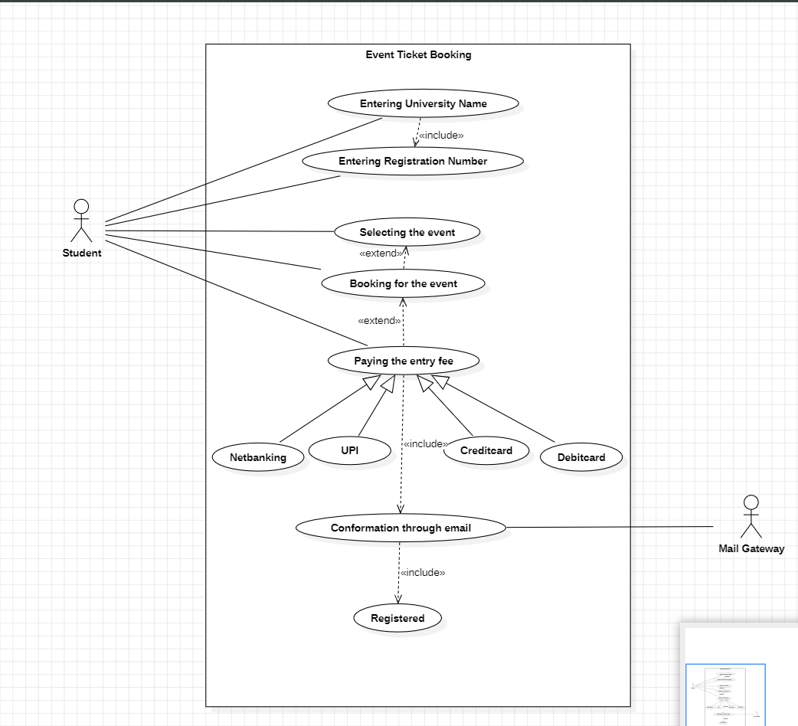
Secondary Actors: Mail Gateway

Fig.1: Event Ticket Booking

ii) Module 2:Events Modification
Description: Event Modification allows organizers to easily update event
details like date, time, venue, or ticket information, ensuring participants
always receive accurate and up-to-date information.

Primary Actors: Event Organizers

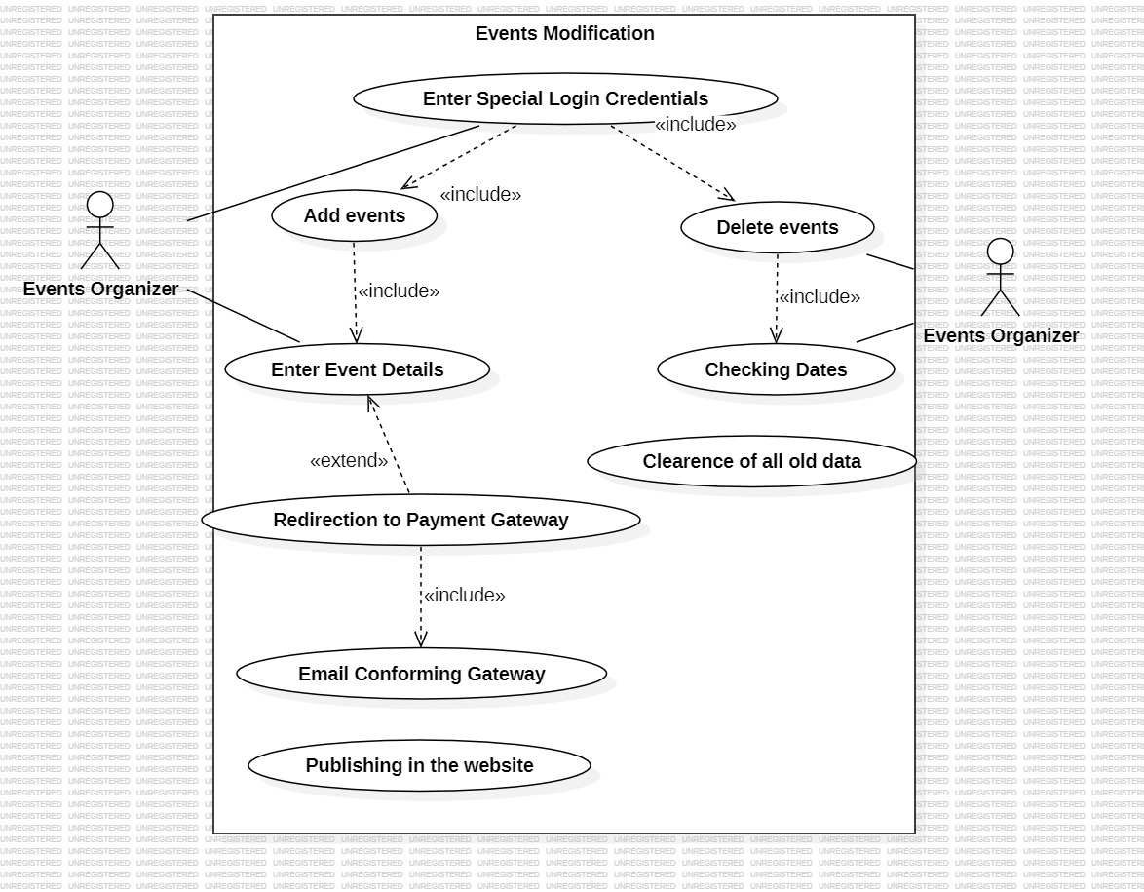
Fig.2: Events Modification

iii)Module 3:Payment refunding
Description: Payment Refunding ensures users get their money back
quickly and safely when a booking is cancelled or fails, making the
process simple, transparent, and stress-free.

Primary Actors:Student
Secondary Actors:1.Payment Gateway
2.Mail Gateway

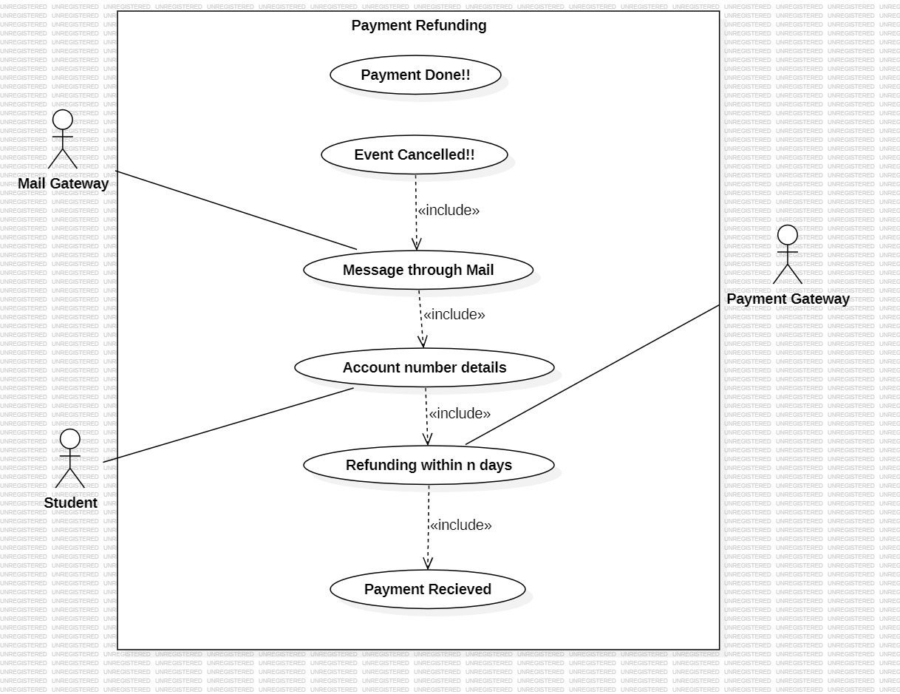
Fig.3: Payment refunding
iv) Module 4:User Account and Profile management
Description:User Account and Profile Management allows users to easily create and manage their accounts. Users can update personal details, change passwords, view booking history, and smooth event booking experience.

Primary Actors:Student
Secondary Actors: Email Gateway

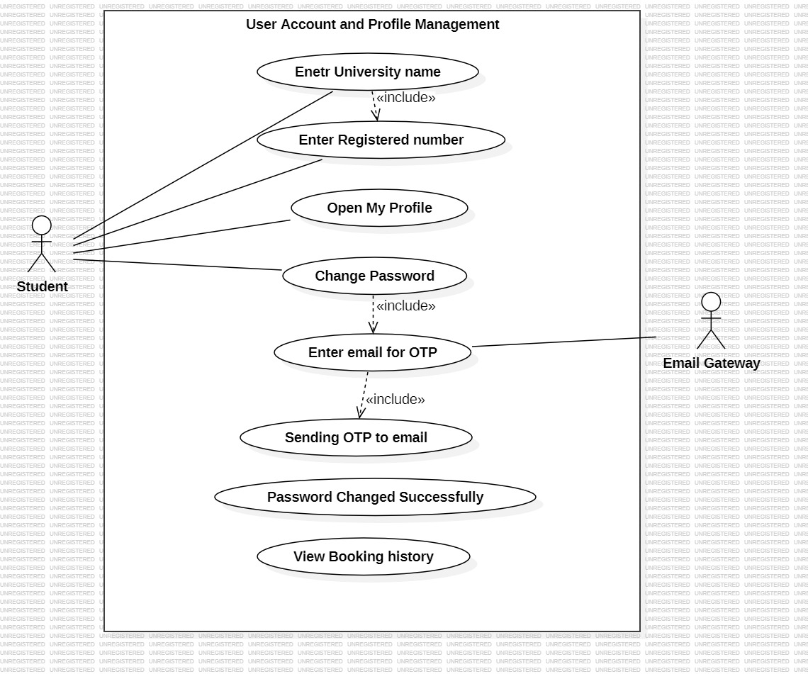

Fig.4: User Account and Profile management
v)Module 5: Review and Feedback
Description: Review and Feedback allows users to share their experiences by rating events and leaving feedback after attending them, helping other users make informed choices and improving overall event quality.

Primary Actors:Student

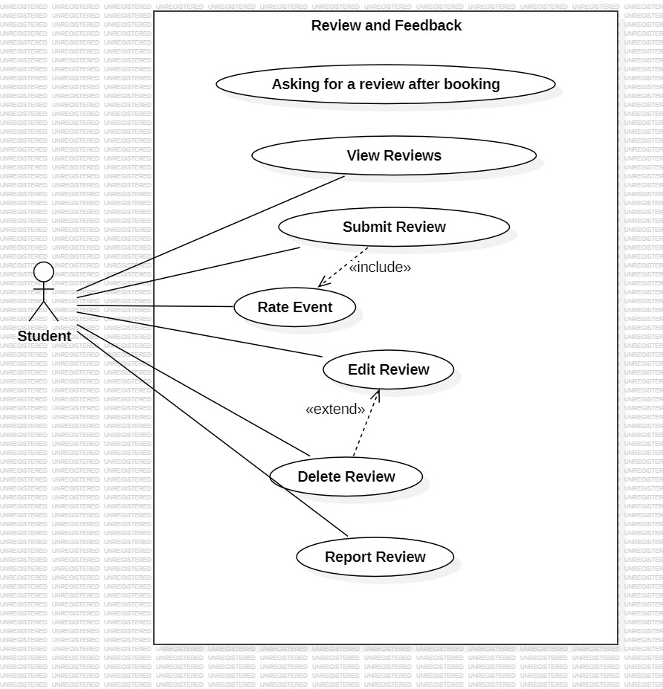

Fig.5:Review and Feedback

b) Class Diagrams:
i) Module 1: Event Ticket Booking
Description: Event Ticket Booking System is a user-friendly platform that allows users to book tickets quickly,without standing in long queues.It makes the booking process smooth, convenient, and time-saving.

Primary Actors:Student
Secondary Actors: Mail Gateway

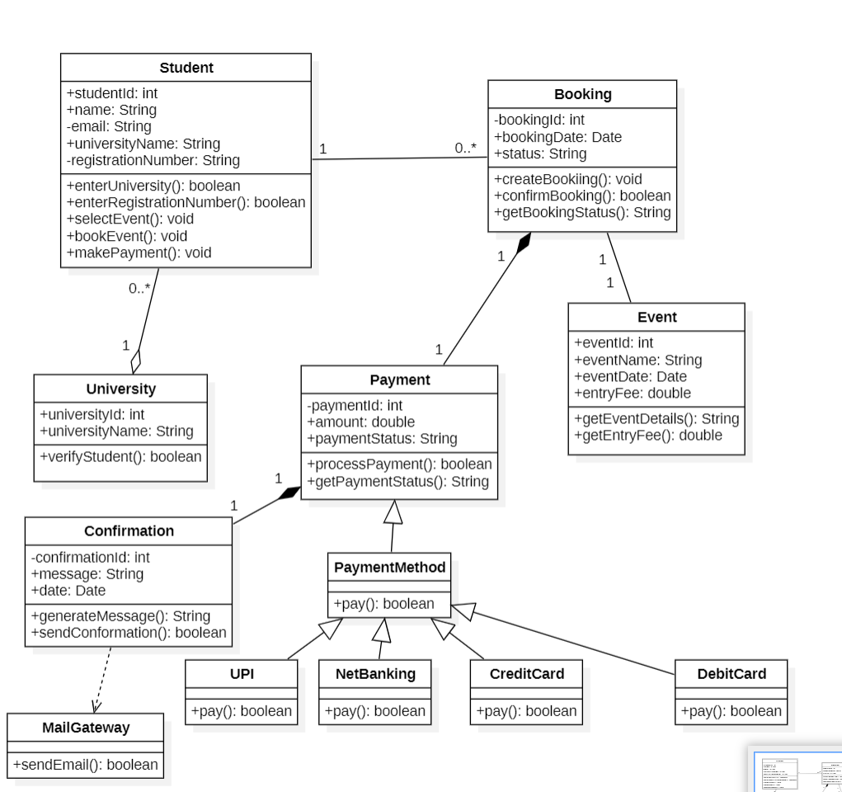

Fig.6: Event Ticket Booking
ii) Module 2:Events Modification
Description: Event Modification allows organizers to easily update event
details like date, time, venue, or ticket information, ensuring participants
always receive accurate and up-to-date information.

Primary Actors: Event Organizers
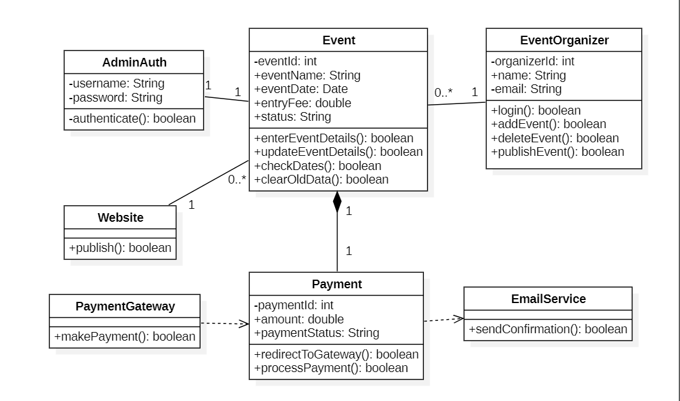
Fig.7: Events Modification

iii)Module 3:Payment refunding
Description: Payment Refunding ensures users get their money back
quickly and safely when a booking is cancelled or fails, making the
process simple, transparent, and stress-free.

Primary Actors:Student
Secondary Actors:1.Payment Gateway
2.Mail Gateway

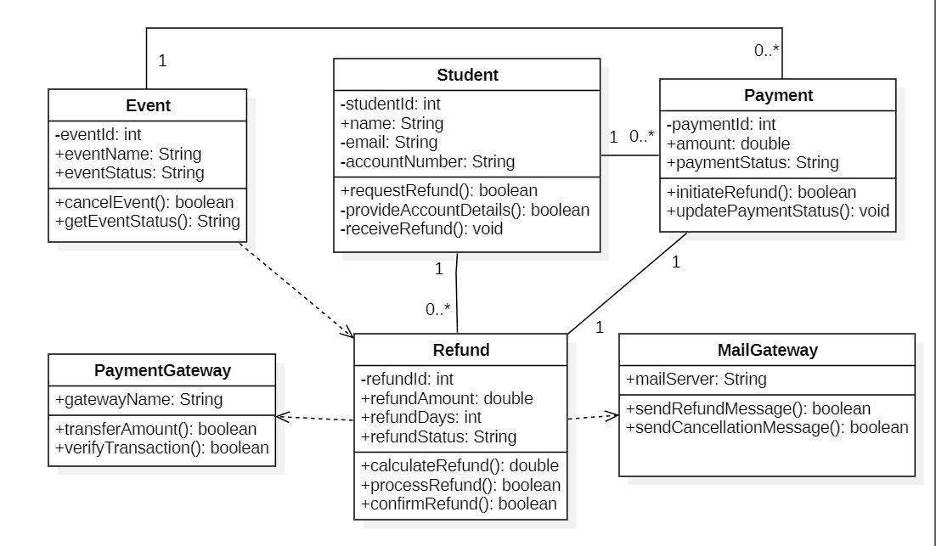
Fig.8: Payment refunding

iv) Module 4:User Account and Profile management
Description:User Account and Profile Management allows users to easily create and manage their accounts. Users can update personal details, change passwords, view booking history, and smooth event booking experience.

Primary Actors:Student
Secondary Actors: Email Gateway
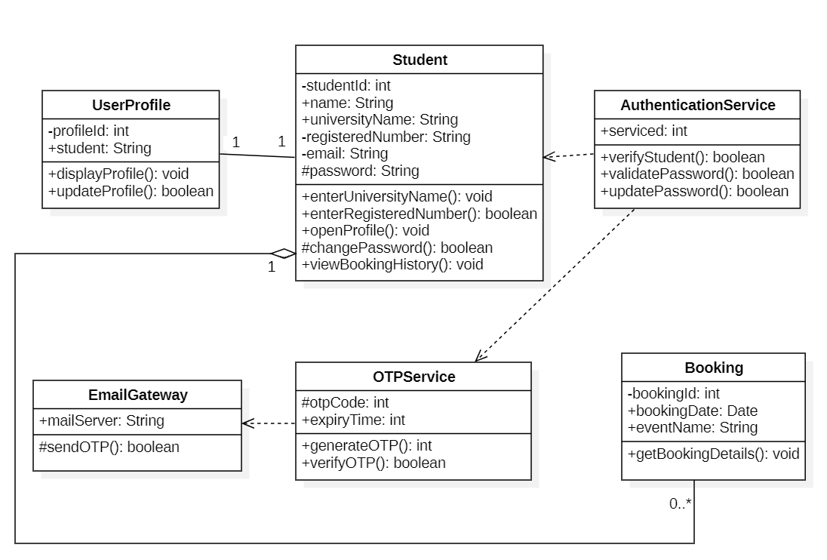
Fig.9: User Account and Profile management

v) Module 5: Review and Feedback
Description: Review and Feedback allows users to share their experiences by rating events and leaving feedback after attending them, helping other users make informed choices and improving overall event quality.

Primary Actors:Student
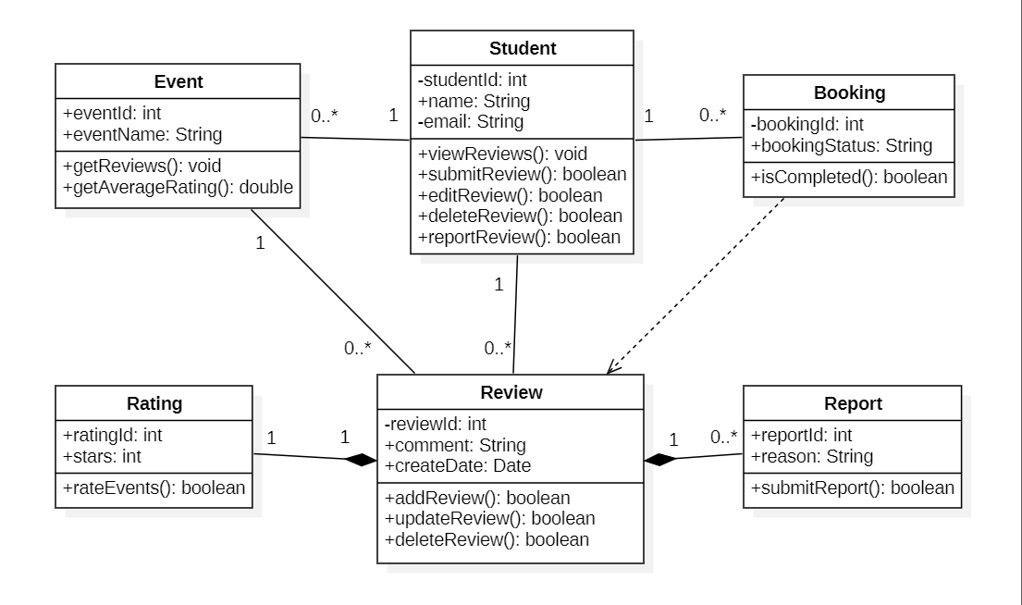

Fig.10: Review and Feedback

c) State Chart Diagram:
i) Module Name:Payment Refunding
1.Student Object
Description: It shows the different states of a student and how thestudent changes from one state to another based on actions like registration, login, and participation.

States Involved:
- Student Logged in
- Account Details Provided
- Refund Requested
- Refund Received
- Invalid Credentials Entered

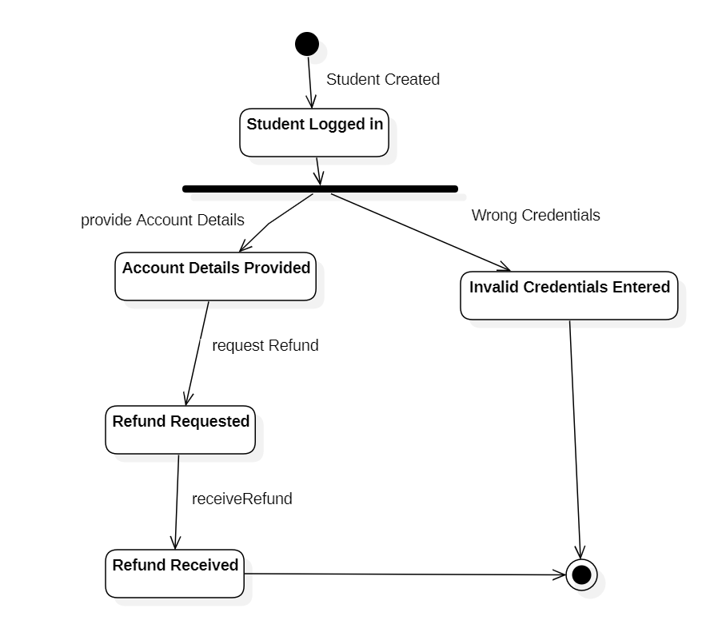

Fig.11: Student Object State diagram
2.Event Object
Description:The Event object stores information about an event such as name, data, and entry fee. It maintains the event’s status and provides event for booking.

States Involved:
- Event Created
- Event Status
- Active
- Cancelled
- Paid
- Unpaid
- Refunding

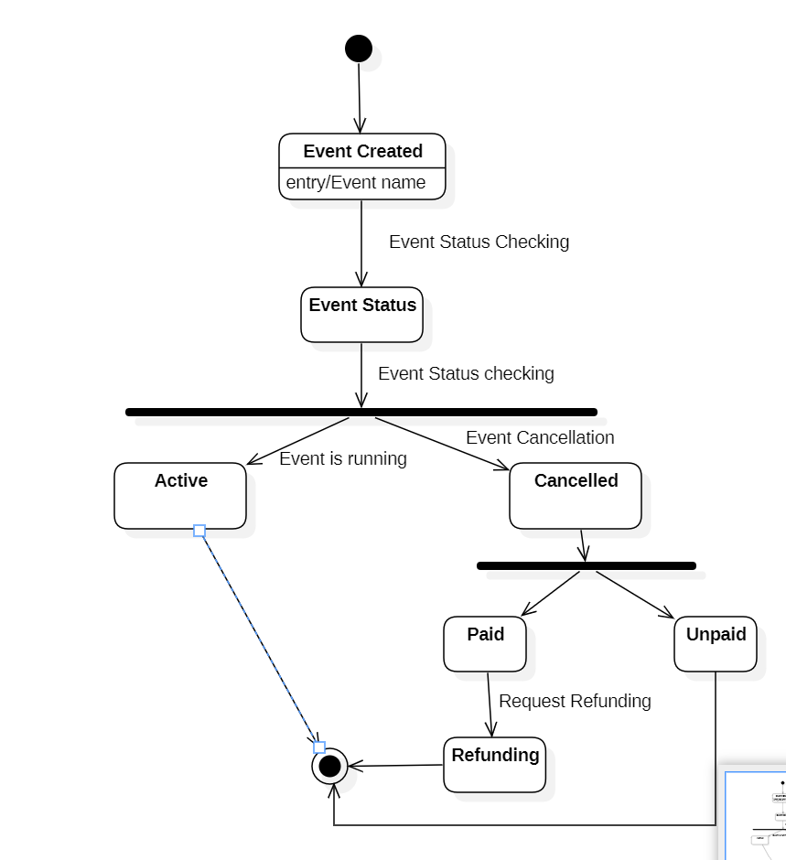

Fig 12: Event Object State Diagram
3.Payment Object:
Description:The Payment object handles the payment made by a student for an event booking. It stores payment details and maintains the current payment status.

States Involved:
- Payment initiated
- Payment Successful
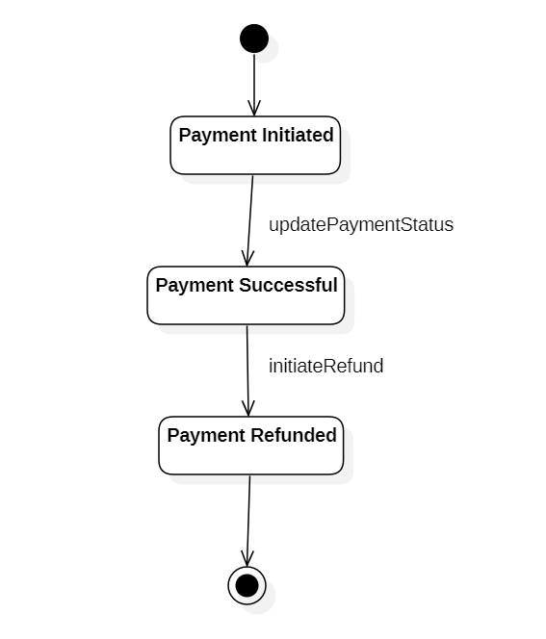
- Payment Refunded

Fig 13: Payment Object State Diagram

4.Refund Object:
Description:The Refund object manages the refund process for a cancelled event or failed booking. It stores refund details and maintains the current refund status.

States Involved:
- Refund Created
- Refund Calculated
- Refund Processing
- Refund Confirmed
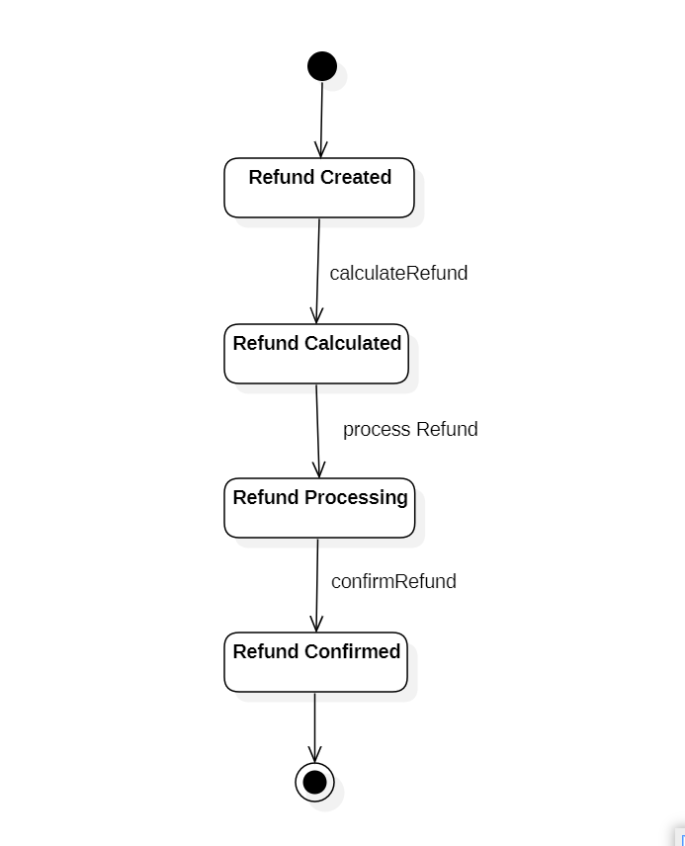

Fig 14: Refund Object State Diagram
5.Payment Gateway Object:
Description:The Payment Gateway object handles verification and transfer of payment or refund amounts. It communicates with the system to confirm transaction success or failure.

States Involved:
- Refunding Requested
- Transaction Verified
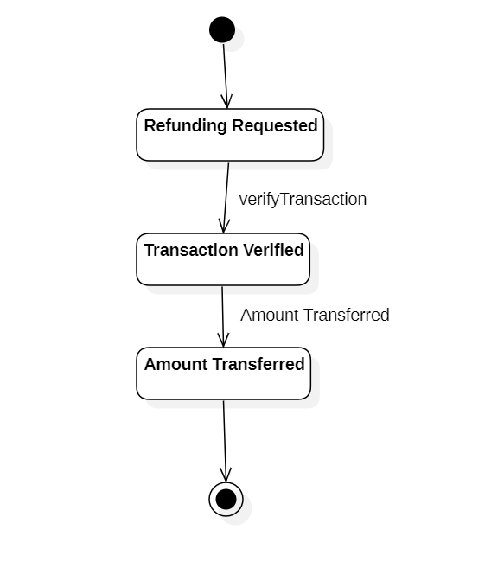
- Amount Transferred

Fig 15: Payment Gateway Object State Diagram

6.Email Gateway Object:
Description:The Email Gateway object handles sending confirmation and notification emails. It ensures users are informed about bookings, payments, or refunds.

States Involved:
- Mail Ready
- Refund Message Sent

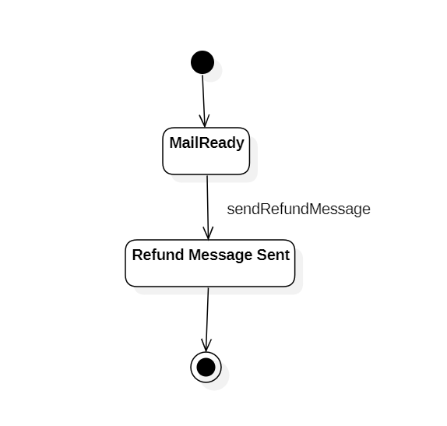

Fig 16: Email Gateway Object State Diagram

d) Activity Diagram:
i) Module Name: Event Ticket Booking
Description:Event Ticket Booking System is a user-friendly platform that allows users to book tickets quickly,without standing in long queues.It makes the booking process smooth, convenient, and time-saving.

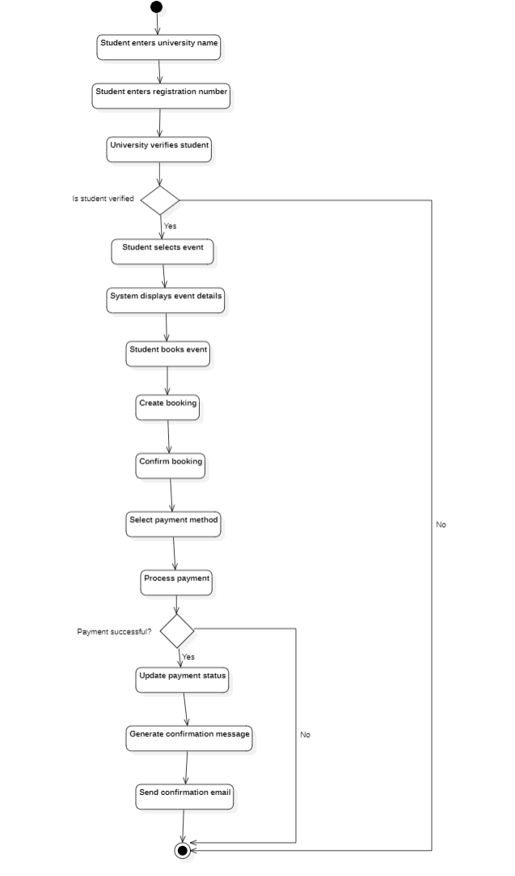

Fig 17: Event Booking Module
ii) Module Name: Events Modification
Description: Event Modification allows organizers to easily update event
details like date, time, venue, or ticket information, ensuring participants
always receive accurate and up-to-date information.
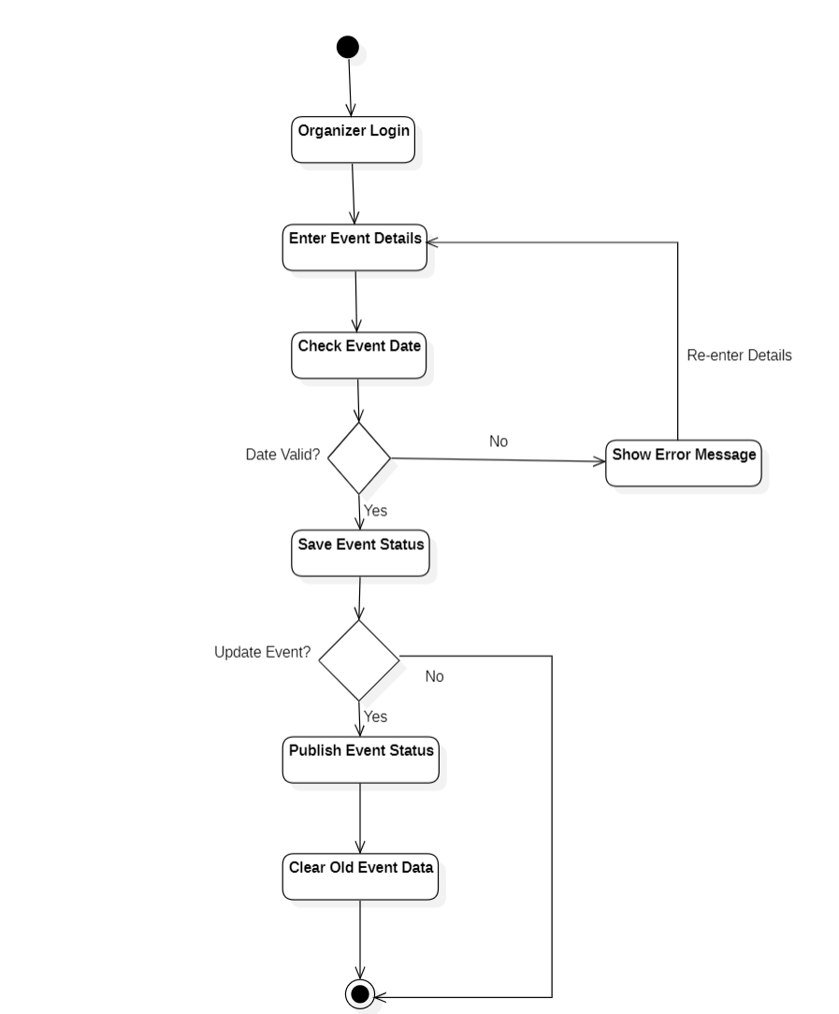

Fig 18: Events Modification Module
e)Sequence Diagram:
i)Module 1: Event Ticket Booking
Description:Event Ticket Booking System is a user-friendlyplatform that allows users to book tickets quickly,without standing in long queues.It makes the booking process smooth, convenient, and time-saving.
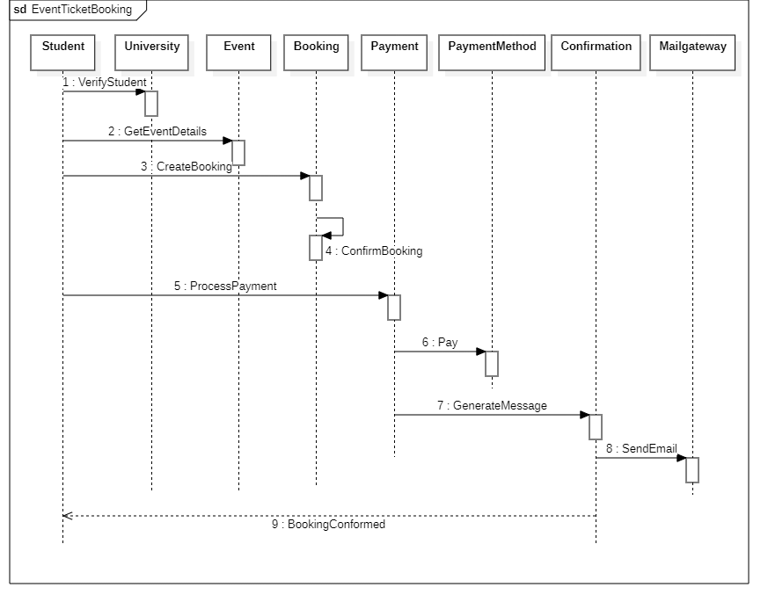

Fig-19: Event Booking Sequence Diagram

ii) Module 2: Events Modification
Description: Events Modification allows organizers to easily update event details like date, time, day, venue, ticket info.
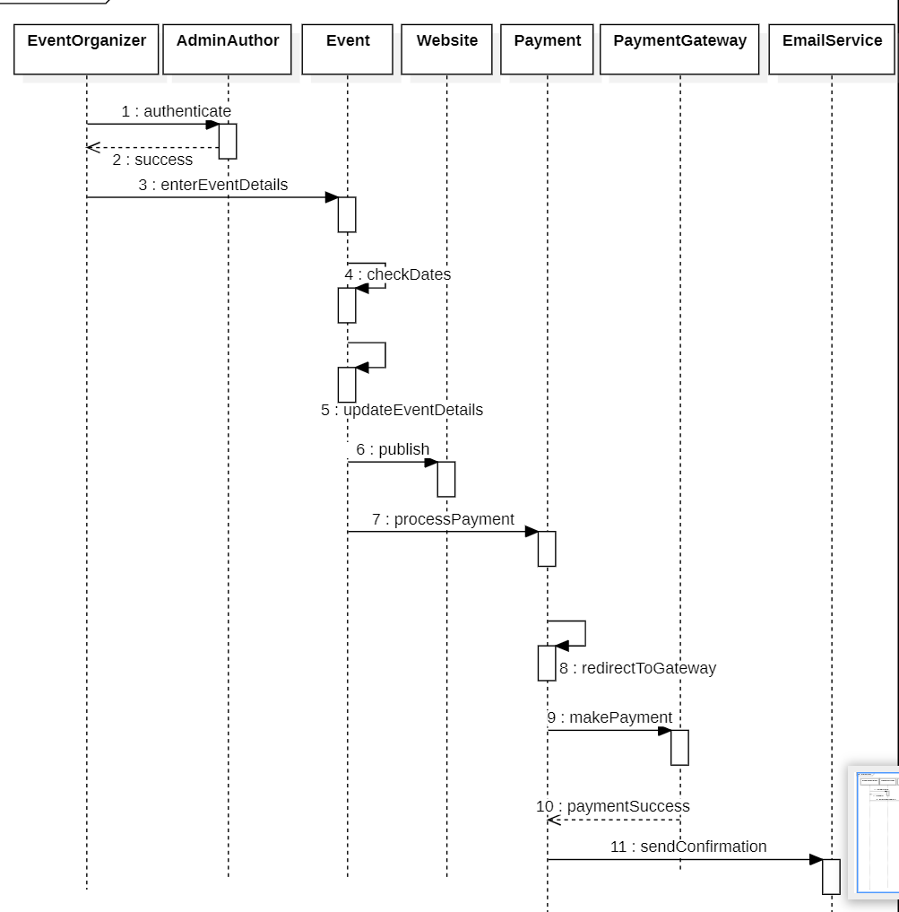
Fig-20: Events Modification Sequence diagram

iii)Module 3:Payment refunding
Description: Payment Refunding ensures users get their money back
quickly and safely when a booking is cancelled or fails, making the
process simple, transparent, and stress-free.

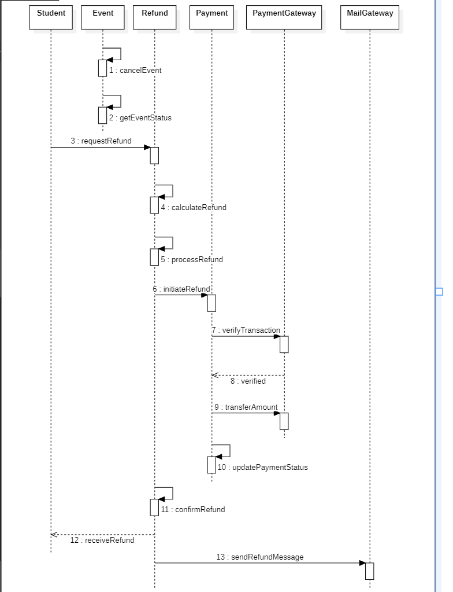
Fig-21: Payment Refunding Sequence diagram

iv) Module 4:User Account and Profile management
Description:User Account and Profile Management allows users to easily create and manage their accounts. Users can update personal details, change passwords, view booking history, and smooth event booking experience.
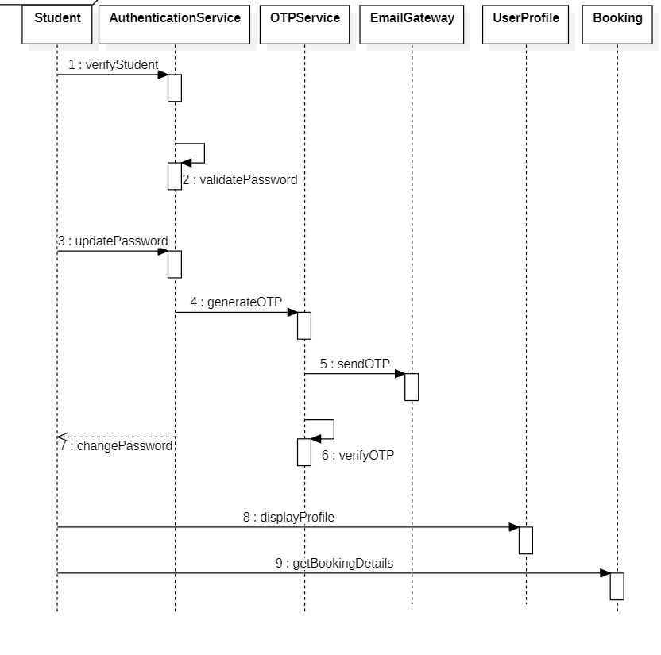

Fig-22:User Account and Profile management Sequence diagram

f) Collaboration Diagram:
i)Module 1: Event Ticket Booking
Description:Event Ticket Booking System is a user-friendlyplatform that allows users to book tickets quickly,without standing in long queues.It makes the booking process smooth, convenient, and time-saving.
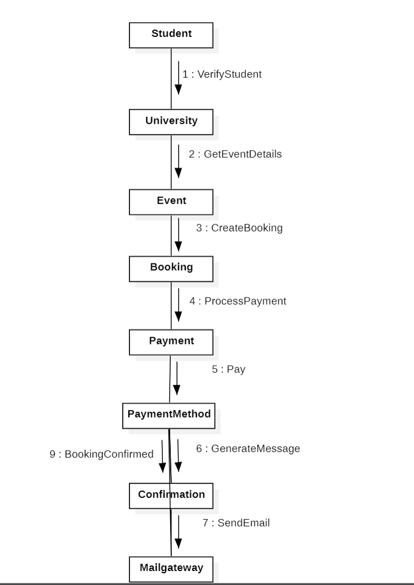
Fig-23:Event Booking Collaboration diagram
ii) Module 2: Events Modification
Description: Events Modification allows organizers to easily update event details like date, time, day, venue, ticket info.
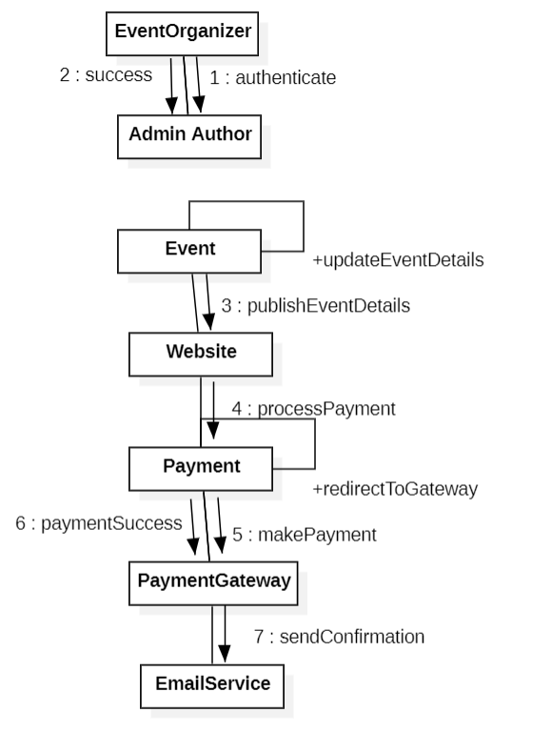
Fig-24: Events Modification Collaboration diagram

iii)Module 3:Payment refunding
Description: Payment Refunding ensures users get their money back
quickly and safely when a booking is cancelled or fails, making the
process simple, transparent, and stress-free.

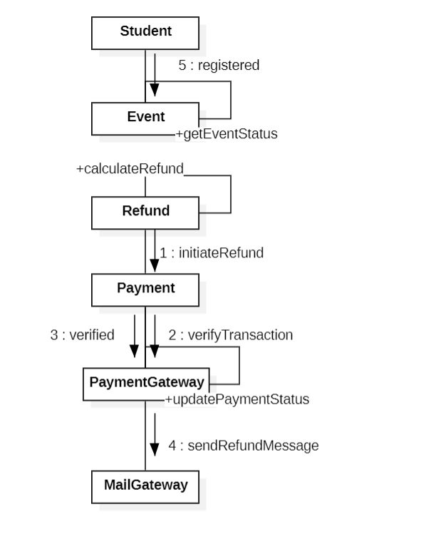
Fig-25: Payment Refunding Collaboration diagram

iv) Module 4:User Account and Profile management
Description:User Account and Profile Management allows users to easily create and manage their accounts. Users can update personal details, change passwords, view booking history, and smooth event booking experience.
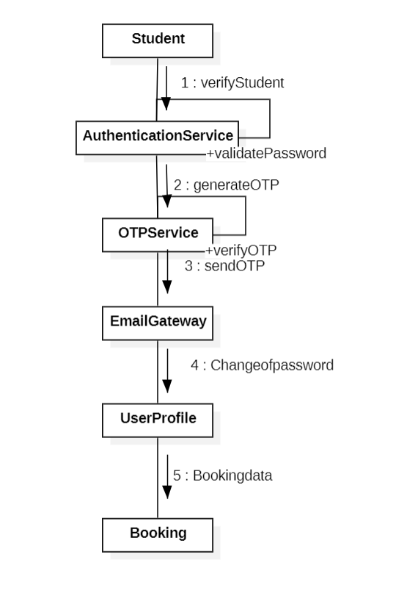
Fig-26: User Account and Profile management Collaboration diagram

3.2 ER Diagram:
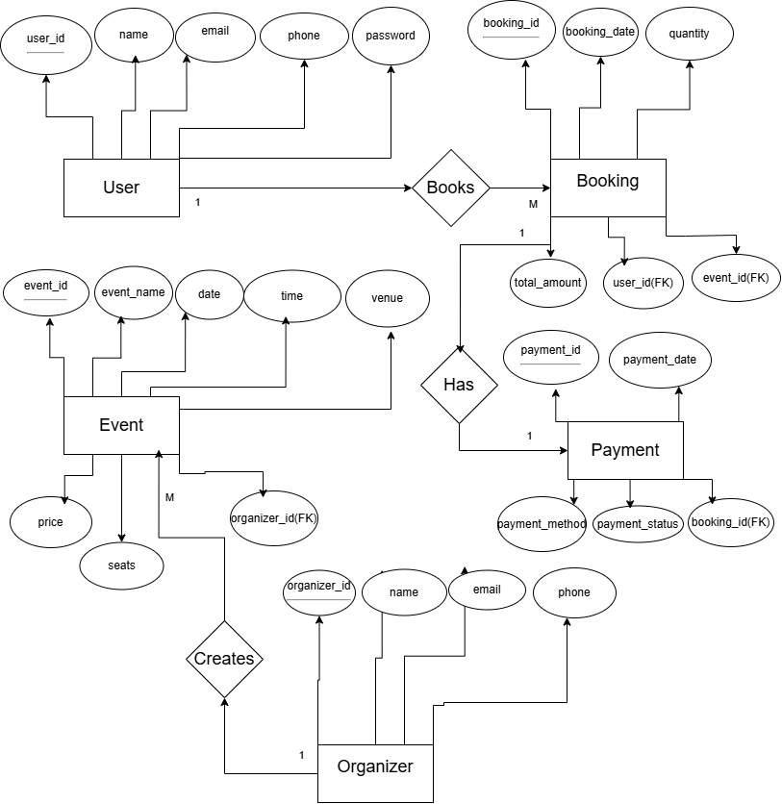
The ER Diagram represents the structure of the Event Ticket Booking System database. It shows the main entities such as User, Event, Booking, Payment, Organizer, and Ticket along with their attributes and relationships. Fig-27: ER Diagram
3.3 DFD Diagram:
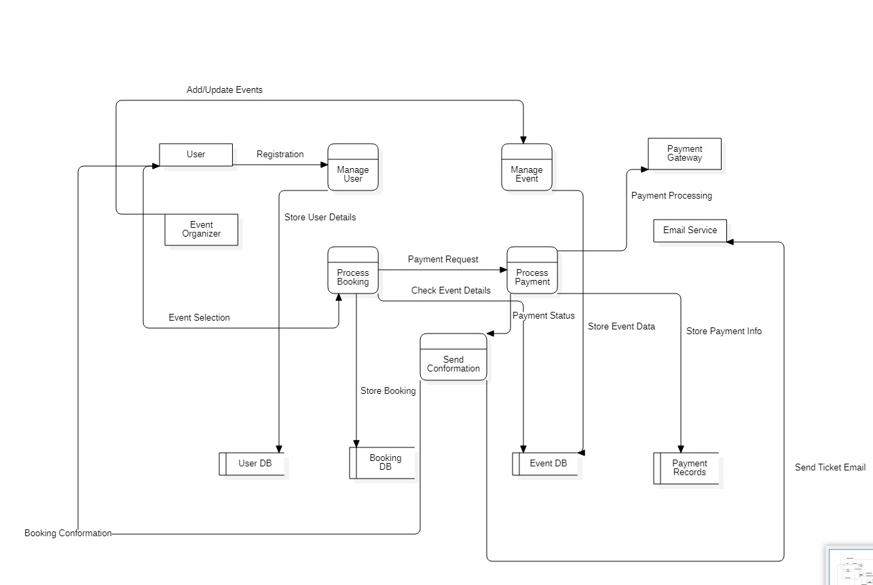
The Data Flow Diagram(DFD) illustrates how data moves within the Event Ticket Booking System . It shows the interaction between external entities such as User and Organizer, the system processes, and data stores. 4.EXTERNAL INTERFACE REQUIREMENTS
External Interface Requirements describe how users and external systems interact withEvent Ticket Booking System.

4.1 User Interfaces:
The Event Ticket Booking System shall provide a responsive, web-based user interface accessible through standard web browsers on desktops, laptops, tablets, and smartphones.

The system shall:

- Provide secure user registration and authentication functionality.
- Allow users to search, filter, and view available events.
- Display detailed event information including event name, date, time, venue,
Ticket categories, and pricing.
- Enable users to select seats and book tickets.
- Provide a secure online payment interface.
- Display booking confirmation along with ticket details after successful payment.
- Allow users to view booking history and cancel tickets.
- Provide an organizer interface to create, update, and manage events.

4.2 Hardware Interfaces:
The system shall operate on the following hardware platforms:

- Desktop and laptop computers
- Smartphones and tablets
- Printer devices for optional ticket printing
The system requires a stable internet connection for all online operations.

4.3 Software Interfaces:
The system shall interface with:

- A relational database management system for storing user, event, booking, and payment data.
- Third-party payment gateway services for secure transaction processing.
- Email service providers for sending booking confirmations and notifications.
- Web browsers such as Google Chrome, Microsoft Edge, and Mozilla Firefox.

4.4 Communication Interfaces:
The system shall use secure communication protocols for data transmission.

- All data exchange shall occur over HTTPS.
- Payment transactions shall be processed using encrypted communication channels.
- Email services shall be used for user notifications.

5.OTHER NON-FUNCTIONAL REQUIREMENTS
Non-functional requirements define the quality attributes and operational constraints of the system. They do not describe features, but explain how well the system should perform.

5.1 Perfomance Requirements:
- The system shall respond to user requests within 3-5 seconds under normal load conditions.
- The system shall support multiple users accessing the system simultaneously.
- The payment process shall be completed without unnecessary delay.
- The system shall handle peak traffic during popular event booking efficiently.

5.2 Safety Requirements:
- The system shall prevent data loss by maintaining regular database backups.
- Automatic recovery mechanisms shall be provided in case of system failure.
- Error messages shall be displayed clearly without exposing system internal details.
- Failed or incomplete payment transactions shall not generate tickets.
- The system shall prevent duplicate seat booking for the same event.
- User data shall be protected from accidental deletion.
- Booking and payment records shall remain consistent even during unexpected shutdowns.
- The system shall maintain logs of critical operations.

5.3 Security Requirements:
- The system shall provide secure user authentication using username and password.
- User passwords shall be stored in encrypted format.
- All transactions shall be processed over secure HTTPS protocol.
- The system shall prevent unauthorized access to user and payment data.
- Session timeout shall be implemented after a period of inactivity.

5.4 Software Quality Attributes:
1.Reliability:
The system shall function correctly and consistently with minimal downtime.

2.Usability:
The system shall provide a simple, user-friendly, and easy-to-navigate interface.

3.Scalability:
The system shall support future growth in users, events, and transactions.

4.Maintainability:
The system shall be easy to update, modify, and debug.

5.Availability:
The system shall be accessible anytime with a stable internet connection.

5.5 Business Policies/Rules:
    - Users must register before booking tickets.
    - Tickets shall be generated only after successful payment.
    - Users cannot book the same seat more than once.
    - Cancellations shall follow the event cancellation policy.
    - Refunds shall be processed according to defined refund rules.
    - Organizers are responsible for providing accurate event details.
    - The system administrator has full control over system management.

6.Testing
6.1 White Box Testing:
Sample Code-1:
Module-4: User Account and Profile Management

def validate_login(username, password):
correct_username = "admin"
correct_password = "12345"

if username == correct_username and password == correct_password:
return True
else:
return False

# Main Program
user = input("Enter username: ")
pwd = input("Enter password: ")

if validate_login(user, pwd):
print("Login Successful")
else:
print("Invalid Credentials")

6.1.1 Flow Graph Notation
• Control flow depicts a program as a graph that consists of Nodes and Edges.
• In the graph, Nodes represent processing tasks while edges represent control flow between the nodes.

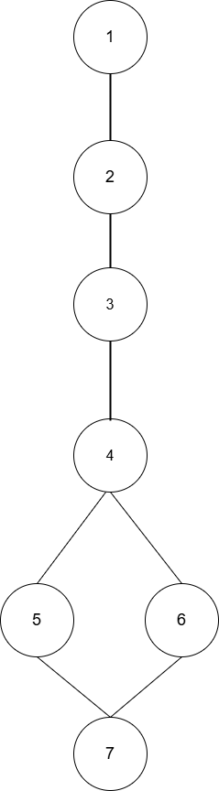

Fig. 28: Flow graph notation for a Sample Code-1

6.1.2 Cyclomatic Complexity
(Using Graph Method)
Here N= 7
E= 7
Where E= Number of edges
N= Number of nodes

V(G) = E-N+2

V(G) = 7-7+2 =2

6.1.3 Independent Program Paths
As Cyclomatic Complexity = 2

That means: It must identify 2 independent paths

Path 1 – Valid Login
1, 2, 3, 4, 5, 7

Path 2 – Invalid Login
1, 2, 3, 4, 6,7

Independent Paths & Test

Path No | Independent Path(Node Sequence) | Test Input | Expected Output
P1 | 1,2,3,4,5,7 | [“admin”, “12345”] | “Login Succesful”
P2 | 1,2,3,4,6,7 | [“admin”, “7865”] | “Invalid Credentials”

6.1.4 Implement Unit Tests (Execution Phase)

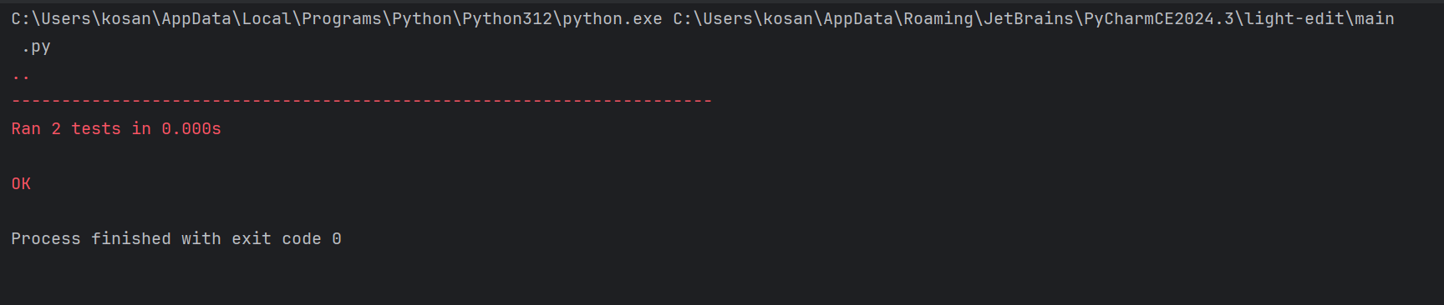
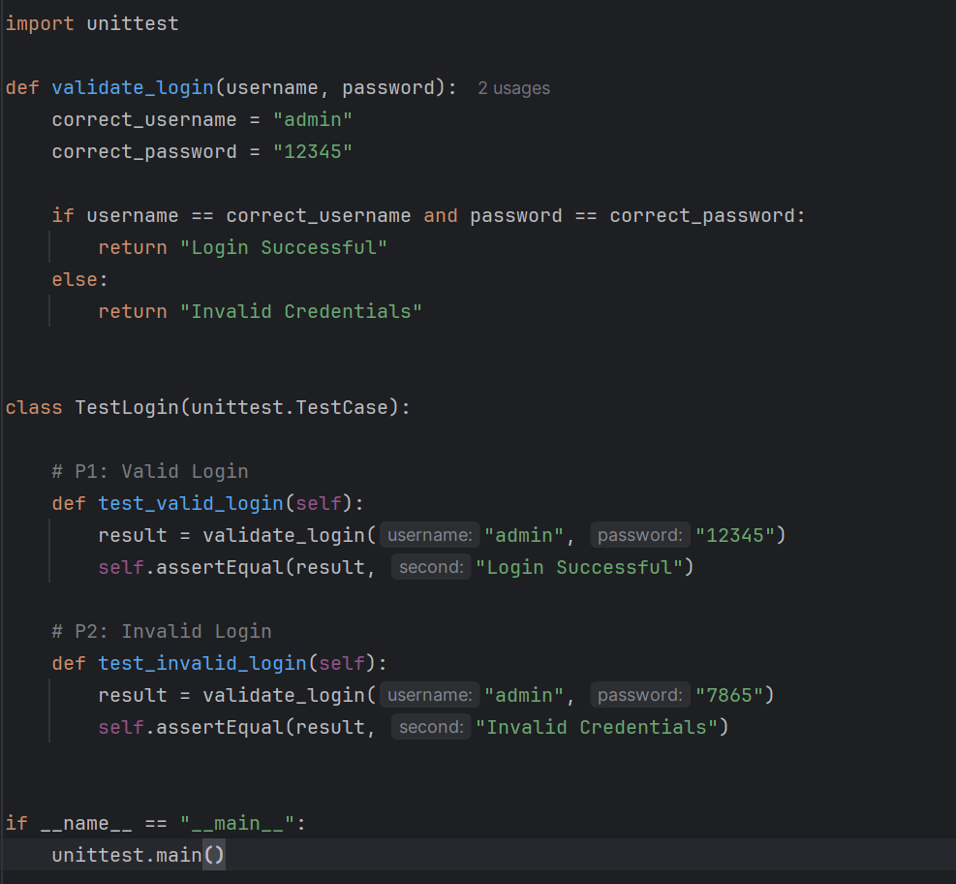
Convert the above table into Python unittest

All tests passed
So, white-box testing is Successful.

6.2 Black-Box Testing
Functional behavior verified without analyzing internal code.

Sample Code-01:

Module-4:User Account and Profile Management

def validate_login(username, password):
correct_username = "admin"
correct_password = "12345"

if username == correct_username and password == correct_password:
return True
else:
return False

# Main Program
user = input("Enter username: ")
pwd = input("Enter password: ")

if validate_login(user, pwd):
print("Login Successful")
else:
print("Invalid Credentials")

Step-1:Write Functional Requirements (From Problem Statement)

For validate_login() module:
☐ System shall define the correct username as "admin"
☐ System shall define the correct password as "12345"
☐ System shall accept username and password as inputs to the login validation function
☐ System shall compare the entered username with the stored correct username
☐ System shall compare the entered password with the stored correct password
☐ If both username and password are correct → function shall return True
☐ If either username or password is incorrect → function shall return False

Step-2: Black Box Testing Techniques

2.1 Equivalence Partitioning:

Divide inputs into logical groups:

For Username Input:

Class | Condition | Valid/Invalid
EC1 | Username=”admin” | Valid
EC2 | Username!=”admin” | Invalid
EC3 | Username is empty | Invalid

For Password Input:
Class | Condition | Valid/Invalid
EC4 | Password=”12345” | Valid
EC5 | Password!=”12345” | Invalid
EC6 | Password is empty | Invalid

For Login Credentials:

Class | Condition | Result
EC7 | Correct username+ Correct password | Login Successful
EC8 | Correct username+ Wrong password | Invalid Credentials
EC9 | Wrong username+ Correct password | Invalid Credentials
EC10 | Wrong username+ Wrong password | Invalid Credentials

2.2 Boundary Value Analysis:

Boundary Values for Username Length:

BB No | Test Value(Username) | Type | Expected Output
BB1 | “”(length=0) | Invalid(Below min) | Invalid Credentials
BB2 | “a”(length=1) | Valid length(min) | Invalid Credentials
BB3 | “admin”(exact) | Valid(correct) | Depends on password

Boundary Values for Password Length:

BB No | Test Value(Username) | Type | Expected Output
BB4 | “”(length=0) | Invalid(Below min) | Invalid Credentials
BB5 | “1”(length=1) | Valid length(min) | Invalid Credentials
BB6 | “12345”(exact) | Valid(correct) | Depends on username

Combined Boundary Test Cases:

BB No | Username | Password | Type | Expected Output
BB7 | “” | “12345” | Username below boundary | Invalid Credentials
BB8 | “admin” | “” | Password below boundary | Invalid Credentials
BB9 | “a” | “1” | Minimum valid lengths | Invalid Credentials
BB10 | “admin” | “12345” | Exact boundary correct values | Login Successful

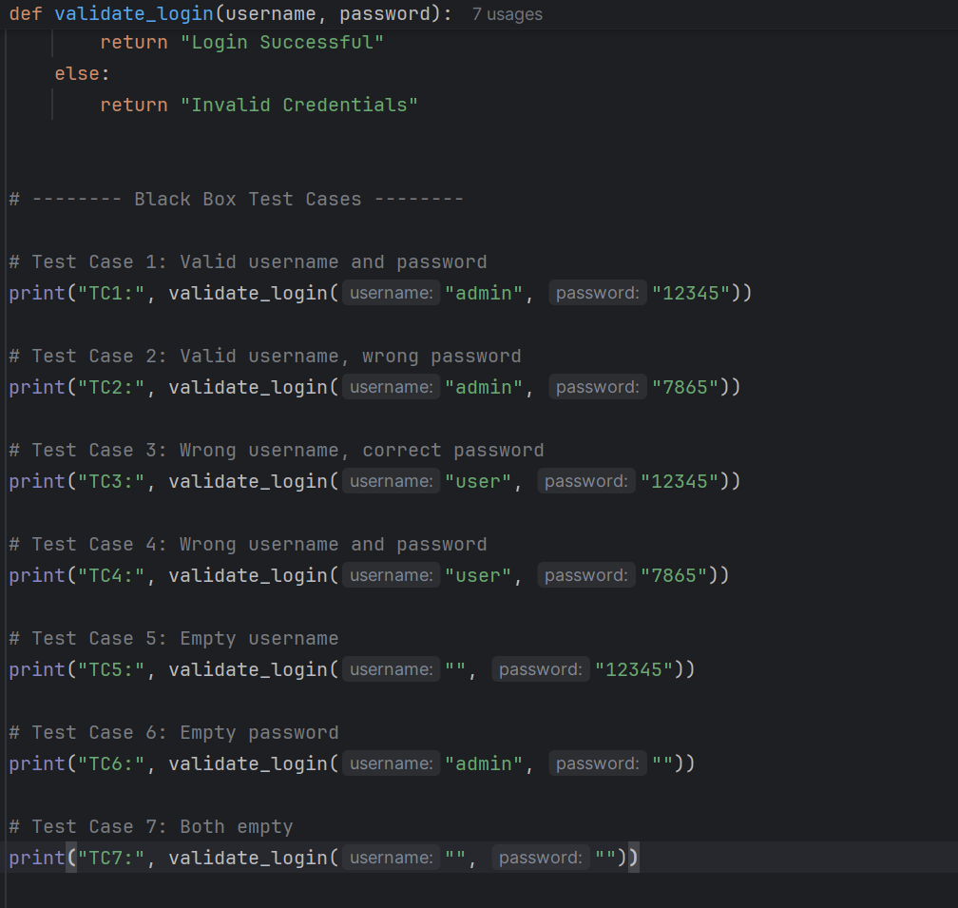
Run the Program manually or using function calls.
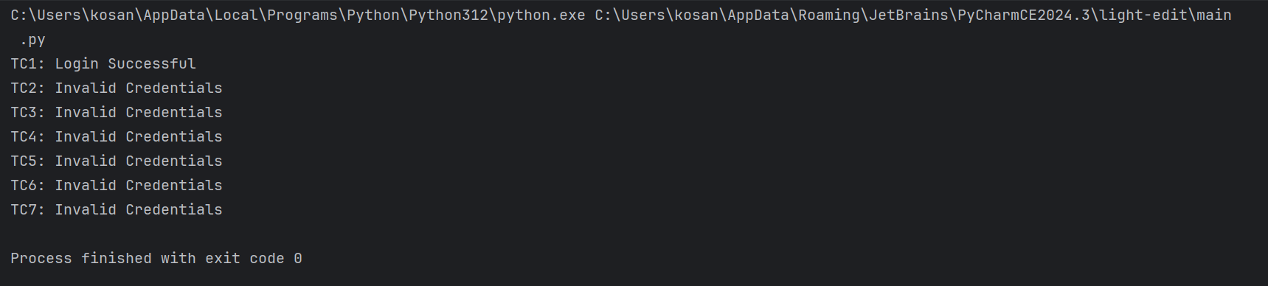

The Output is matched to all the above test cases mentioned in table, then Black Box testing is successful.

6.1 White Box Testing:
Sample Code-2:
Module-1: Event Ticket Booking

def calculate_total_tickets(no_of_tickets, price_per_ticket):
if no_of_tickets<= 0:
return 0

total = no_of_tickets * price_per_ticket

# 10% discount if more than 5 tickets
if no_of_tickets> 5:
total = total - (0.10 * total)

return total

# Main Program
tickets = int(input("Enter number of tickets: "))
price = float(input("Enter price per ticket: "))

total_amount = calculate_total_tickets(tickets, price)
print("Total Amount:", total_amount)

6.1.1 Flow Graph Notation
• Control flow depicts a program as a graph that consists of Nodes and Edges.
• In the graph, Nodes represent processing tasks while edges represent control flow between the nodes.

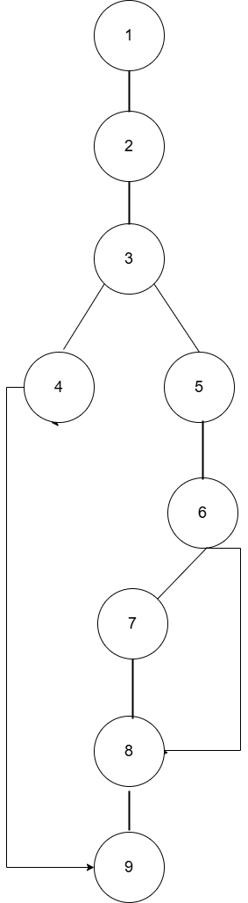

Fig. 29: Flow graph notation for a Sample Code-2

6.1.2 Cyclomatic Complexity
(Using Graph Method)
Here N= 9
E= 10
Where E= Number of edges
N= Number of nodes

V(G) = E-N+2

V(G) = 10-9+2 =3

6.1.3 Independent Program Paths
As Cyclomatic Complexity = 3

That means: It must identify 3 independent paths

Path 1 – Tickets<=0
1, 2, 3, 4, 9

Path 2 – 1<Tickets<5
1, 2, 3, 4, 5, 6, 8, 9

Path 3 – Tickets>5(Discount applied)
1, 2, 3, 5, 6, 7, 8, 9

Independent Paths & Test

Path No | Independent Path(Node Sequence) | Test Input | Expected Output
P1 | 1,2,3,4,9 | Tickets=-1,price=100 | 0
P2 | 1,2,3,4,5,6,8,9 | Tickets=3,price=100 | 300
P3 | 1,2,3,5,6,7,8,9 | Tickets=6,price=100 | 540

6.1.4 Implement Unit Tests (Execution Phase)

Convert the above table into Python unittest.
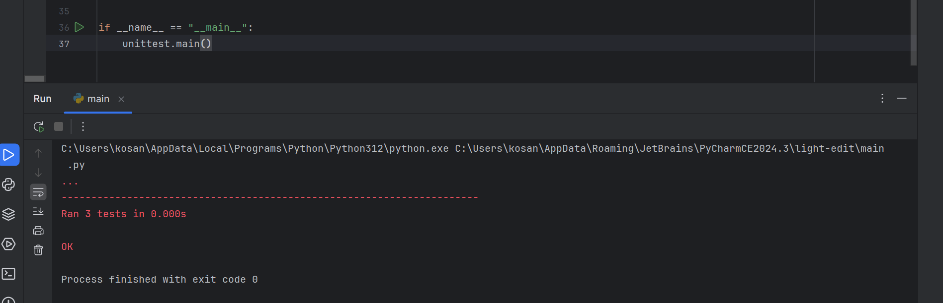
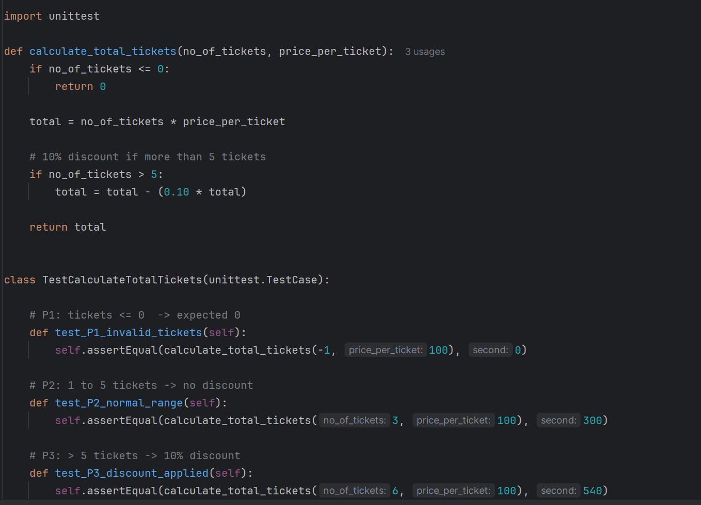

All tests passed
So, white-box testing is Successful.

6.2 Black-Box Testing
Functional behavior verified without analyzing internal code.

Sample Code-02:

Module-1:Event Ticket Booking

def calculate_total_tickets(no_of_tickets, price_per_ticket):
if no_of_tickets<= 0:
return 0

total = no_of_tickets * price_per_ticket

# 10% discount if more than 5 tickets
if no_of_tickets> 5:
total = total - (0.10 * total)

return total

# Main Program
tickets = int(input("Enter number of tickets: "))
price = float(input("Enter price per ticket: "))

total_amount = calculate_total_tickets(tickets, price)
print("Total Amount:", total_amount)

Step-1:Write Functional Requirements (From Problem Statement)

For calculate_total_tickets() module:
☐ System shall accept no_of_tickets and price_per_ticket as inputs.
☐ System shall validate the number of tickets entered by the user.
☐ If no_of_tickets ≤ 0, the system shall return 0 as total amount.
☐ If no_of_tickets> 0, the system shall compute
total = no_of_tickets × price_per_ticket.
☐ System shall check whether the user booked more than 5 tickets.
☐ If no_of_tickets> 5, the system shall apply 10% discount on the total amount.
☐ System shall return the final total amount after applying discount (if applicable).

Step-2: Black Box Testing Techniques

2.1 Equivalence Partitioning:

Divide inputs into logical groups:

For Number of Tickets

Class | Condition | Type
EC1 | Tickets<=0 | Invalid
EC2 | 1<= Tickets <=5 | Valid
EC3 | Tickets>5 | Valid(Discount applied)

For Price Per Ticket

Class | Condition | Type
EC4 | Price<=0 | Invalid
EC5 | Price>0 | Valid

2.2 Boundary Value Analysis:

Boundary Identification(Tickets)

Boundary Point | Meaning | Type
0 | Last invalid value(tickets<=0) | Invalid boundary
1 | First valid value | Lower valid boundary
5 | Last value without discount | Upper normal boundary
6 | First value with discount(tickets>5) | Discount boundary

Boundary Test Cases

BB NO | Tickets | Price | Expected Output
BB1 | 0 | 100 | 0
BB2 | 1 | 100 | 100
BB3 | 5 | 100 | 500
BB4 | 6 | 100 | 540

Run the Program manually or using function calls.
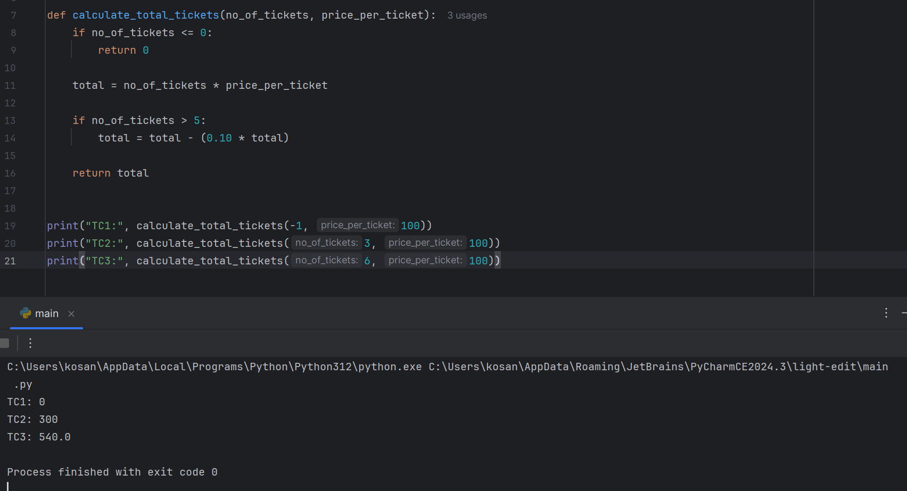

The Output is matched to all the above test cases mentioned in table, then Black Box testing is successful.

7.Conclusion
The Software Requirement Specification(SRS) document for the Event Ticket Booking System provides a description of the system’s functional requirements, non-functional requirements, and overall system architecture. The system is designed to simplify the process of browsing events, booking tickets, making payments, and receiving booking confirmations through an user-friendly platform.

The system enables users to easily view event details, select tickets, complete secure payments, and receive notifications regarding their bookings. It also ensures proper management of user information, event details, and booking records through organized database components.

By clearly defining system requirements, this document serves as a foundation for system design, development, testing. The Event Ticket Booking System aims to reduce manual effort, and provide a convenient ticket booking experience for users. Future improvement may include advanced features such as enhanced security mechanisms to further improve system performance and usability.

8.References
- Pressman, R. S., & Maxim, B. R. (2020). Software Engineering: A Practitioner’s Approach (9th ed.). McGraw-Hill Education.

- Sommerville, I. (2016). Software Engineering (10th ed.). Pearson Education.

- IEEE Computer Society. (2018). IEEE Recommended Practice for Software Requirements Specifications (IEEE Std 830). IEEE.

- Object Management Group. (2017). Unified Modeling Language (UML) Specification. Retrieved from https://www.omg.org/uml

- Diagrams.net. (2024). Draw.io Diagram Tool Documentation. Retrieved from https://www.diagrams.net

9.Acknowledgements
We would like to express our sincere gratitude to our faculty and institution for providing us with the opportunity to work on the Event Ticket Booking System project. Their guidance and support helped us understand the concepts of software engineering and system design more effectively.

We also extend our thanks to our project guide for their valuable suggestions and encouragement throughout the development of this project. Their insights helped us improve the quality of our work and complete the project successfully.

Finally, we would like to thank our classmates and friends for their support and cooperation during the preparation of this Software Requirement Specification (SRS) document.

DESIGN PHASE

Description:
The design phase of the Event Ticket Booking System describes the structure and deployment of the system using UML diagrams.

- Component Diagram:
The component diagram represents the major software components of the Event Ticket Booking System and their interactions. It illustrates how components such as the User Interface, Login, Event Management, Booking, Payment, Notification, and databases communicate with each other through defined interfaces and dependencies to perform the ticket booking process.

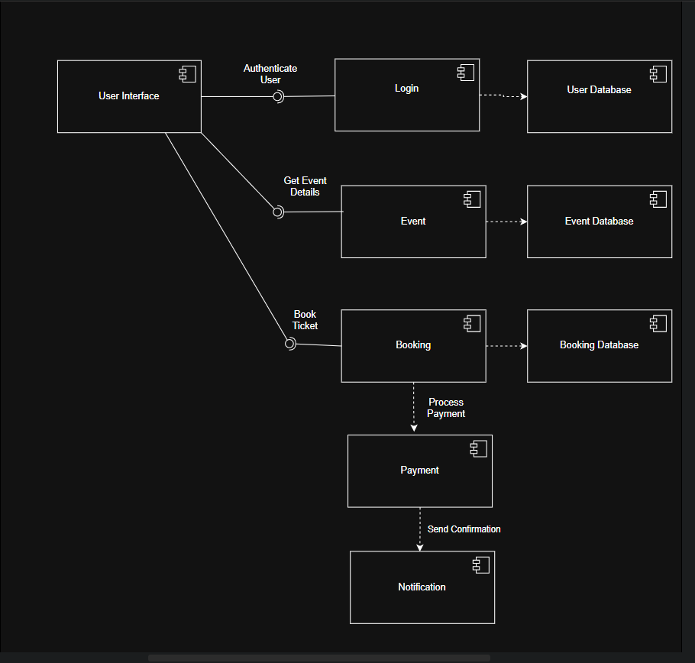

Fig. 30: Component Diagram

2.Deployment Diagram:
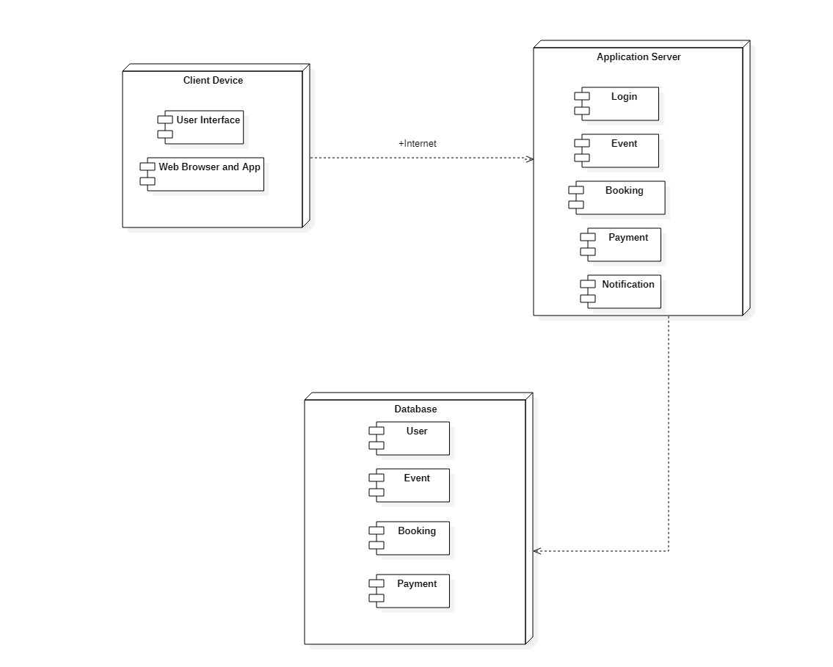
The deployment diagram illustrates the physical architecture of the Event Ticket Booking System. It shows how the system is deployed across different nodes such as the client device, application server, and database server, and how these components communicate with each other through network connections.

Fig. 31: Deployment Diagram

PRODUCT METRICS FOR SYSTEM ANALYSIS

1.Product Metrics:
Product metrics measures the quality and the functionality of the software product. For the Event Ticket Booking System, these metrics help evaluate:

- System functionality
- Complexity
- Maintainability
- Performance

2.Analysis Model Metrics:
Analysis model metrics estimate the size and complexity of the system during requirement analysis.

For the Event Ticket Booking System, the main metrics include:

1)External Inputs (EIs): 5

Inputs are data entered by the user.

Examples:
      - User registration
      - Login details
      - Event creation details
      - Ticket booking information
      - Payment details

2)External Outputs (EOs): 5

Outputs are responses generated by the system.

Examples:
- Booking confirmation
- Ticket details
- Payment receipt
- Event list
- Booking history

3)External Inquiries (EQs):4
User inquiries are requests where users retrieve information without modifying data.

Examples:
- Search events
- View event details
- Check seat availability
- View booking history

4)Internal Logical Files (ILFs):4
ILFs are data stored and maintained by the system.

Examples:
- User database
- Event database
- Ticket booking database
- Payment records

5)External interface Files (EIFs):2
ELFs are data used by the system but maintained by another system.

Examples:
- Payment gateway database
- External notification system

3.Function Point Calculation:
Step 1: Calculate UFP(Unadjusted Function Points)

Component | Count | Weight | Total
External Inputs(EI) | 5 | 4 | 5*4=20
External Outputs(EO) | 5 | 5 | 5*5=25
External Queries(EQ) | 4 | 4 | 4*4=16
Internal Logical Files(ILF) | 4 | 10 | 4*10=40
External Interface Files(ELF) | 2 | 7 | 2*7=14

Total UFP=20+25+16+40+14=115
UFP=115

4.Complexity Adjustment Factor(CAF):
CAF formula

CAF=0.65+(0.01*sigma(Fi))

Where,
0.01 is a scaling factor
0.65 is a base adjustment value.

- Assume all 14 factors

The Value adjustment factors

- Reliable backup and recovery required? – Score: 4 – Booking and payment data must be securely stored and recoverable.

- Specialized data communication required? – Score: 3 – The system communicates with payment gateway and notification services.

- Distributed processing functions present? – Score: 2 – Web application connected with database and payment services.

- Is performance critical? – Score: 4 – Fast search, booking, and payment processing are required.

- Runs in heavily used environment? – Score: 3 – Multiple users may access the system simultaneously.

- Online data entry required? – Score: 5 – Users register, login, search events, and book tickets online.

- Multi-screen online data entry required? – Score: 4 – Booking includes event selection, seat selection, and payment steps.

- ILFs updated online? – Score: 5 – User, event, and booking data are updated in real time.

- Inputs/outputs/files complex? – Score: 3 – Moderate complexity in bookings, receipts, and event queries.

- Internal processing complex? – Score: 4 – Seat availability checking and ticket generation require processing logic.

- Code designed for reuse? – Score: 3 – Modules like login, payment, and notifications can be reused.

- Conversion and installation included? – Score: 1 – Minimal conversion needed for this system.

- Multiple installations required? – Score: 2 – System could be used by different event organizers.

- Designed for change and ease of use? – Score: 4 – User-friendly interface and future scalability supported.

Sigma(Fi)=4+3+2+4+3+5+4+5+3+4+3+1+2+4=47

CAF=0.65+(0.01*Sigma(Fi)

CAF=0.65+(0.01*47)
CAF=0.65+0.47
CAF=1.12

5.Final Function Point:
FP=UFP*CAF
FP=115*1.12
FP=128.8

Therefore,
Function Point(FP)=128.8

Therefore,
Total Estimated Cost isRs.12,88,000

What 128.8 Function Points Means?

The value 128.8 Function Points represents the functional size of the Event Ticket Booking System after adjusting for system complexity using the Complexity Adjustment Factor (CAF).

It indicates that the software is a moderately complex system with features such as user registration, event browsing, ticket booking, payment processing, booking history, and admin event management.

Development Effort Estimation
Historically, in software engineering:
$$1\text{ Function Point}=10\text{ development hours} \\ 128.8×10=1288\text{ hours}$$
Estimated development effort:
$$1288\text{ hours}$$

Project Duration Based on Number of Developers

Number of Developers | Estimated Cost
1 Developer | 1288 hours
2 Developers | 644 hours
3 Developers | 429 hours
4 Developers | 322 hours

Example:
If 4 developers work 6 hours per day:
$$322÷6=53.6≈54\text{ days}$$
Estimated project duration = about 8 weeks

Productivity Measurement
Developer productivity can be measured as:
$$\text{Productivity}=\frac{128.8}{1288}=0.1\text{ FP/hour}$$
Productivity = 0.1 FP/hour

Possible Number of Errors
Industry average:
Errors per Function Point = 0.5 – 1
Estimated errors:
$$128.8×0.7=90.16≈90\text{ errors}$$
Estimated errors = 90

Error Fixing Effort
Assume average time to fix one error = 3 hours
$$90×3=270\text{ hours}$$
Error fixing effort = 270 hours

Fixing Cost
If developer cost = ₹1000 per hour
$$270×1000=2,70,000$$
Error fixing cost = ₹2,70,000 /-

Testing Effort
Testing usually requires 30% – 40% of development effort.
Taking average as 35%:
$$1288×0.35=450.8≈451\text{ hours}$$
Testing effort = 451 hours

Testing Cost
$$451×1000=4,51,000$$
Testing Cost = ₹4,51,000 /-

Total Project Cost
Development Cost = ₹12,88,000 /-
Error Fixing Cost = ₹2,70,000 /-
Testing Cost = ₹4,51,000 /-
$$=12,88,000+2,70,000+4,51,000 \\ =20,09,000$$
Final Estimated Cost
Total Estimated Project Cost = ₹20,09,000 /-

EMPIRICAL ESTIMATION
MODEL
(COCOMO MODEL)

COCOMO MODEL:
The COCOMO (Constructive Cost Model) is a standard method used in software engineering to estimate the effort, cost, and schedule required for a software project. Introduced by Barry Boehm in 1981, it relies on historical data and mathematical formulas to predict project outcomes based primarily on the size of the software.

There are 2 Types of Models:
- Basic COCOMO Model
- Intermediate COCOMO Model

1.Basic COCOMO Model:
The Basic COCOMO can be used for quick and slightly rough calculations of Software Costs.

The following formulas are used to calculate effort and time estimates:

Effort ( E ) = A*(KLOC)^B

Time (T) = C*(Effort)^D

Persons required = Effort / Time

The constant values A, B, C and D for the Basic Model for the different categories of software
projects.

Software Project | A | B | C | D
Organic | 2.4 | 1.05 | 2.5 | 0.38
Semi Detached | 3.0 | 1.12 | 2.5 | 0.35
Embedded | 3.6 | 1.20 | 2.5 | 0.32

The Event Ticket Booking System is a Small Organic Project, With a Size of 10KLOC.

A=2.4
B=1.05
C=2.5
D=0.38

Effort = 2.4 × (10)^1.05
= 2.4 × 11.22
≈ 26.93 person-months

Time = 2.5 × (26.93)^0.38
≈ 2.5 × 3.50
≈ 8.75 months

Persons required = 26.93 / 8.75 ≈ 3.08 ≈ 3 persons

Basic COCOMO result of Event Ticket Booking System:
- KLOC = 10
- Effort = 26.93 PM
- Time = 8.75 months
- Team size = 3 persons

2.Intermediate COCOMO Model:
The Intermediate COCOMO model estimates software effort by considering both size (KLOC) and cost drivers. It uses an Effort Adjustment Factor (EAF) to account for factors like product complexity, team capability, and tools, making it more accurate than the basic model.

- In the intermediate COCOMO model, various other factors such as reliability, experience, and
Capability are considered along with LOC to estimate effort and time schedule.

- These factors are known as Cost Drivers and the Intermediate Model utilizes 15 such drivers for
cost estimation

Product attributes
- Required software reliability
Since payment and registration data should be correct, reliability matters.
Rating: High = 1.15

- Size of application database
Database is there, but not huge like banking or hospital systems.
Rating: Nominal = 1.00

3. Product complexity
Your project has login, event handling, registration, payment, email, and DB integration, so complexity is above normal.
Rating: High = 1.15
Hardware attributes
4.Run-time performance constraints
No strict real-time or high-performance requirement.
Rating: Nominal = 1.00

5.Memory constraints
No serious memory limitation.
Rating: Nominal = 1.00

6. Volatility of virtual machine environment
Normal development environment, not highly unstable.
Rating: Nominal = 1.00

7.Required turnabout time
No urgent machine turnaround requirement.
Rating: Nominal = 1.00

Personnel attributes
8.Analyst capability
For a student project, we can keep this at average.
Rating: Nominal = 1.00

9. Software engineering capability
Again, average student-team assumption.
Rating: Nominal = 1.00

10. Application experience
You are building this type of project for learning, so domain experience is not very high.
Rating: Low = 1.17

11. Virtual machine experience
Normal experience assumed.
Rating: Nominal = 1.00

12. Programming language experience
You are doing it in Java and have already been working on it, so average is fair.
Rating: Nominal = 1.00

Project attributes
13. Use of software tools
You are using development tools, DB tools, diagram tools, etc., so tool usage is good.
Rating: High = 0.91

14. Application of software engineering methods
Since you are preparing SRS, UML, testing, DFD, ERD, and design properly, methods are above normal.
Rating: High = 0.91

15. Required development schedule
No extreme deadline pressure assumed.
Rating: Nominal = 1.00

Tabular representation:

Cost Drivers | Very Low | Low | Nominal | High | Very High | Extra High
1 |  |  |  | 1.15
2 |  |  | 1.00
3 |  |  |  | 1.15
4 |  |  | 1.00
5 |  |  | 1.00
6 |  |  | 1.00
7 |  |  | 1.00
8 |  |  | 1.00
9 |  |  | 1.00
10 |  | 1.17
11 |  |  | 1.00
12 |  |  | 1.00
13 |  |  |  | 0.91
14 |  |  |  | 0.91
15 |  |  | 1.00

EAF= Product of cost drivers
EAF = 1.15 × 1.00 × 1.15 × 1.00 × 1.00 × 1.00 × 1.00 × 1.00 × 1.00 × 1.17 × 1.00 × 1.00 × 0.91 × 0.91 × 1.00
EAF = 1.2813 ≈ 1.28

The following formulas are used to calculate effort and time estimates:

Effort ( E ) = A*(KLOC)^B*(EAF)

Time (T) = C*(Effort)^D

Persons required = Effort / Time

The Event Ticket Booking System is a Small Organic Project, With a Size of 10KLOC.

A=2.4
B=1.05
C=2.5
D=0.38

Effort
Effort = 3.2 × (10)^1.05 × 1.28
Effort ≈ 46.01 person-months
Development time
Time = 2.5 × (46.01)^0.38
Time ≈ 10.71 months
Team size
Persons required = 46.01 / 10.71
≈ 4.30 ≈ 4 persons

